Express From Within, 2
Engage Your Inner Voice Through Intuitive Art Expression

Tuesday, March 12, 6-8:30 p.m.
at the suite of Attuned Healing
430 South Jackson Street

Facilitated by:
Laura Garrard, Artist & Reiki Master Teacher, Attuned Healing
Lyndsay McCandless, Artist, Spirit Bookstore

Fee $45, which includes materials and a take-home art journal.
Creative tools provided and/or bring your favorite art supplies to be infused with Reiki energy. No experience necessary. Class limited to 8.

Due to popular demand, we are teaching another energy art class for returning and new students! You will create from within and begin or continue an art journal through additional energetically led exercises. Meditation and Reiki energy will guide you to select your art tools, choose your colors and identify themes to express. You will also produce a finished piece encouraged by energetic opening. Let your inner world demonstrate how beautiful and free the heart wants to be.
Call now and reserve your space!

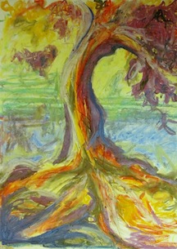

Laura Garrard, Attuned Healing
307-690-5308, attunedhealing@gmail.com

Lyndsay Rowan McCandless, Spirit Bookstore
307-413-4331, lyndsayrowan@gmail.com

